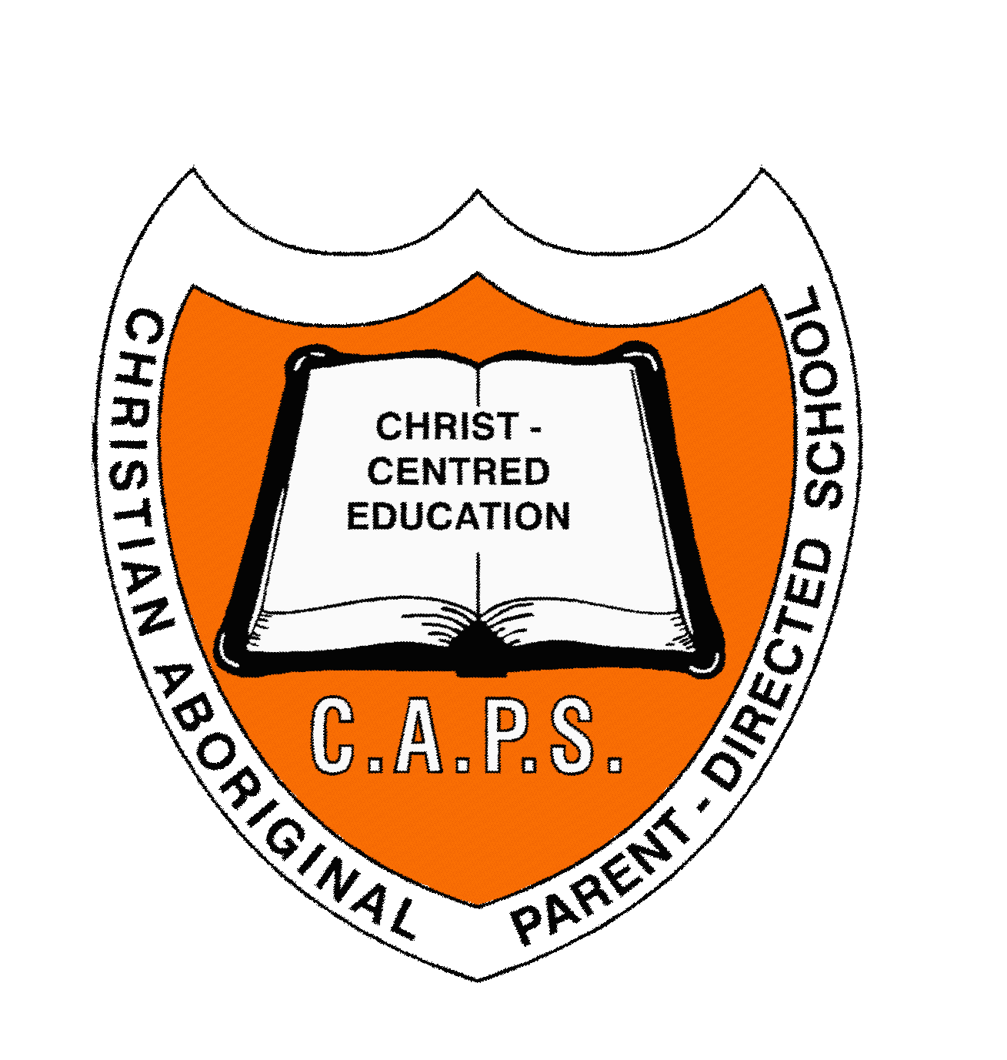

Telephone: (08) 9093 8000

School Fax: (08) 9093 8020

Accounts Fax: (08) 9026 6339

**Email:** [**principal@caps.wa.edu.au**](mailto:principal@caps.wa.edu.au)

**Web:** [**www.caps.wa.edu.au**](http://www.caps.wa.edu.au)

ABN 41 741 294 178

Primary and Secondary Education

85-93 Lindsay Street

PO Box 28

COOLGARDIE WA 6429

Friday 9th December 2022

Dear parent/guardian,

**End of Term 4 Newsletter**

I greet you in Christ’s name. The final school term will end on Thursday 15th of December 2022. We can look back to where we began this year and thank the Lord for His blessings and guidance on our school, board, staff, students and parents and carers.

I would like to share with you some of the highlights of 2022 at CAPS Coolgardie. They are:

1. Our Year 10 and 11 cohort of students sat for the Program for International Student Assessment (PISA) in August. It is a batch of assessments sat by students from the member countries of Organisation for Economic Cooperation & Development (OECD). It was the first time CAPS Coolgardie was chosen to participate in this international assessment program and I am glad we did. The students who sat for the assessments were awarded certificates for representing Australia.
2. The FAME trailer returned in early September and edited the school film it had produced in 2021 to commemorate CAPS Coolgardie’s 40th anniversary. Our students immersed themselves in outdoor learning on the re-designed and magnificent trailer. What a fabulous experience it was!
3. The newly – designed school, sports and hostel uniforms were introduced this year and they are everyone’s favourites. It is the feeling of wearing it that matters and makes the staff happy that the students are enjoying wearing them.
4. The school’s participation at sports carnivals with schools in Kalgoorlie represents a wider involvement by our school to expose our students’ sporting talents. Some of these sporting events are: The Goldfields Basketball Grand Slam, primary soccer carnivals, Cross Country 2022, Goldfields Inter-School Volleyball Competition and Star Foundation Basketball Competition 2022.
5. Various primary and secondary excursions and incursions in the post-covid period were truly uplifting for our students and staff. Some of these are worthy of mention such as the Indigenous Tennis Workshop, WACE secondary camp in Perth, representation by two of our senior girls at the National Student Constitution Conference 2022 in Perth, the Goldfields Young Heroes Tour on resilience and friendship and Year 9 Taster program to establish TAFE pathways for our students.

Please find your child’s semester two academic report attached with this newsletter. It is a notable document that informs you of what your child has achieved in the learning areas he/she has studied this year. Therefore, it needs to be read and talked about with your child.

The school year at CAPS Coolgardie will commence on **Wednesday 1st of February 2023** for both the staff and students. On Monday 30th January the staff will commence with an induction with the school board in Kurrawang and on Tuesday 31st of January 2023, they will be at the school to prepare for your child’s arrival.

On a sad note, my wife Janet and I have resigned from CAPS Coolgardie after working here for fourteen and a half years and will move to teach in a small and remote school in the Pilbara region in 2023. We are sad to leave the school that means a lot to us. Also resigning from CAPS Coolgardie is Mrs Loveness Dale who will pursue further studies in 2023 and Mr Kwibisa and Mrs Mapalo Lufwendo who are returning to Perth for family reasons. I also note Miss Judy Nolan leaving us after doing relief teaching in the early childhood since Term 2. Both the staff and students will miss them in the new year. However, we are confident that the Lord will provide their replacements.

Finally, I would like to wish you and your child a blessed Christmas and a fulfilling new year and leave you with God’s words from Isaiah 9.6-7:

*6 For unto us a child is born, unto us a son is given: and the government shall be upon his shoulder: and his name shall be called Wonderful, Counsellor, The mighty God, The everlasting Father, The Prince of Peace.*

*7 Of the increase of his government and peace there shall be no end, upon the throne of David, and upon his kingdom, to order it, and to establish it with judgment and with justice from henceforth even for ever. The zeal of the Lord of hosts will perform this.*

God bless.

Yours sincerely,

Mr Robert Javapro

Outgoing Principal

[https://encrypted-tbn1.gstatic.com/images?q=tbn:ANd9GcR1t3lIS7iDCQ0Z1CsPcayUBLYPAajM5LiVFlohQMocbtXfFZCRkw](https://www.google.com.au/imgres?imgurl=http://www.playgroupqueensland.com.au/wp-content/uploads/flag.jpg&imgrefurl=https://www.playgroupqueensland.com.au/playgroup-programs-for-families/playgroup-programs/accessible-playgroup/&docid=zQKxRAeA7RWX0M&tbnid=X7292JxvlU_qRM:&w=459&h=180&ei=mQA_VYatHo_xoATXp4DwBQ&ved=0CAIQxiAwAA&iact=c)*I respectfully acknowledge the Indigenous and Torres Strait Islander people as the Traditional Owners of this country throughout Australia, and their connection to land and community. I pay my respect to them and their cultures, and to the Elders both past and present.*